1. ExamRepository.Update() is implemented like this:

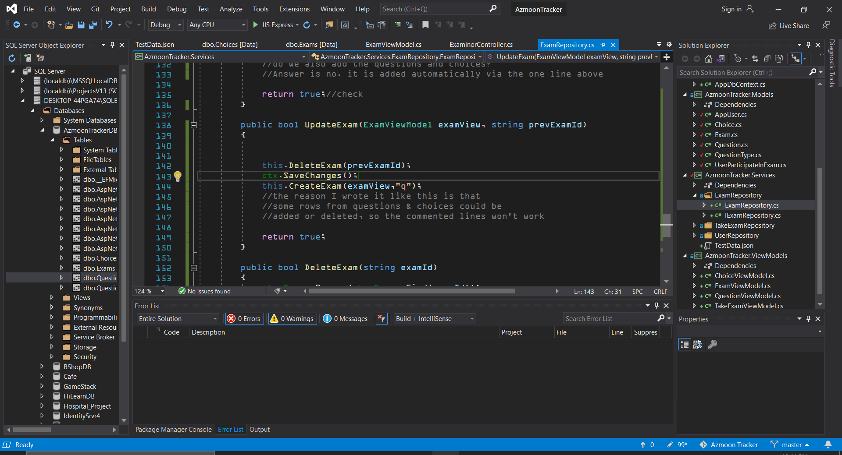

It’s lazy work but runs smoothly.

It is highly prone to attack errors. Fix this by adding some filters before/after it.